Student worksheet

An object in motion remains in motion until a force acts on it

Newton’s first law: Inertia

1 Which of the two shopping trolleys shown in the diagram below has the greatest inertia? Explain your answer.



|  |
| --- |
|  |
|  |

2 The diagram below shows a stack of five coloured circular disks made of smooth, polished wood. Describe the motion of the coloured disks when the plunger is hit quickly and firmly by the hand.

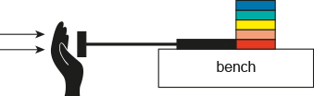

|  |
| --- |
|  |
|  |
|  |

3 The photograph below shows a 4.0-kilogram penguin sliding across a large, flat icy surface with a constant velocity of 2.0 m s–1. Assuming that the surface is frictionless, what size force is required to keep the penguin travelling at this speed?

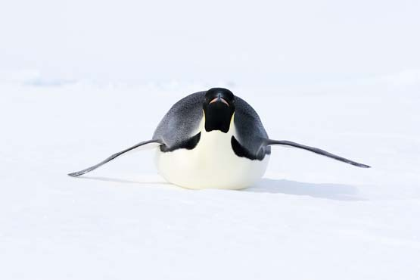

|  |
| --- |
|  |
|  |
|  |
|  |

4 In the diagram below, will the cyclist be travelling in a state of constant motion? Explain your answer.

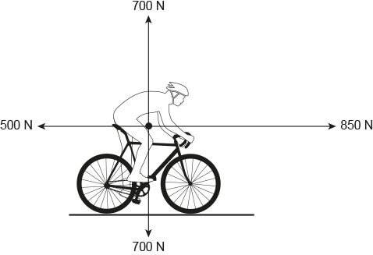

|  |
| --- |
|  |
|  |
|  |
|  |

5 Use your understanding of Newton’s law of inertia to explain how the cyclist got to the position he is in in the following photograph.



|  |
| --- |
|  |
|  |
|  |
|  |
|  |

6 Michaela took a ride on an amusement park ride called the ‘Space Shot’. At ground level at the start of the ride, Michaela said that she felt like she was being pushed very hard downwards into her seat – but that this confused her as she knew that she was moving upwards very quickly. Explain the physics of what Michaela experienced at the start of the ride.

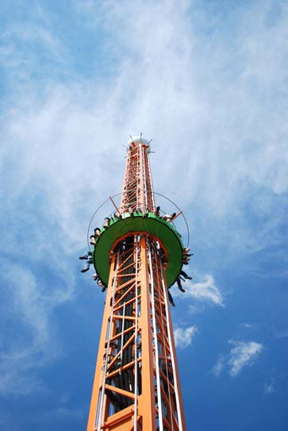

Force equals mass × acceleration

Newton's second law: Fnet = ma

7 Describe Newton’s second law.

|  |
| --- |
|  |
|  |

8 What is the difference between mass and weight?

|  |
| --- |
|  |
|  |

9 What formula can be used to calculate net force?

|  |
| --- |
|  |

10 Complete the equation triangle for net force below and describe how it works.



|  |
| --- |
|  |
|  |
|  |

Where necessary below, use g = 9.80 m s–2. Unit conversions: 1000 grams = 1 kilogram and 1000 kilograms = 1 tonne.

11 How much horizontal net force is required to accelerate a 1200-kg car at 1.5 m s–2?

|  |
| --- |
|  |
|  |
|  |

12 A net force of 16 N gives a bowling ball an initial acceleration of 2.5 m s–2. What is the mass of the bowling ball?

|  |
| --- |
|  |
|  |

13 A speed skater has a mass of 64 kg. She is providing a driving force of 400 N, and there is a frictional force of 240 N against her. Draw these two forces acting on her and then determine her acceleration.



|  |
| --- |
|  |
|  |

8 A skydiver of mass 85 kg is falling through the air at terminal velocity (constant speed).



a What is the weight force acting on the skydiver?

|  |
| --- |
|  |
|  |

b How much air resistance is acting on the skydiver?

|  |
| --- |
|  |
|  |

14. The Airbus A380 has a mass at take-off of 575 tonnes. During take-off, its four engines provide a total thrust of 1300 kN. Its take-off speed is 270 km h–1 and it takes 72 seconds from rest to reach this speed.

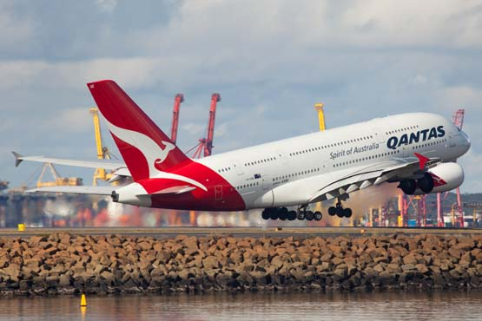

a What is the average acceleration of the A380 during its take-off run? Give your answer correct to two decimal places.

|  |
| --- |
|  |
|  |
|  |
|  |

b What is the average total resistive force acting against the A380 during its take-off run?

|  |
| --- |
|  |
|  |
|  |
|  |

Each action has an equal and opposite reaction

15. For the following two situations, describe the action and reaction forces. Remember that each force acts on a different item in the object pair.

|  |  |  |  |
| --- | --- | --- | --- |
|  | Situation | Action | Reaction |
| a | A rocket taking off from its launch pad.  SW0723_01095-r |  |  |
| b | A tennis racquet hitting a tennis ball.  SW0724_01095-r |  |  |

16. A horse is pulling on a cart. If the cart exerts an equal and opposite force on the horse, how is it possible for the horse to pull the cart so that it moves? Use your understanding of Newton’s laws of motion to explain this situation.



  
  
  
  
  